# **Install OpenJDK For Linux**

**Steps To Install OpenJDK For Linux:**

1. Get the most recent version of OpenJDK from [https://openjdk.java.net/](https://openjdk.org/)

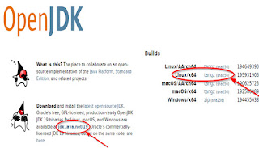

1. Copy openjdk-19.0.2_linux-x64_bin.tar.gz into folder /opt .
2. Go to /opt folder.

|  |
| --- |
| cd /opt |

1. Unzip the file.

|  |
| --- |
| tar -xvf /opt/openjdk-19.0.2_linux-x64_bin.tar.gz |

1. Verify that it can be run.

|  |
| --- |
| /opt/jdk-19.0.2/bin/java -version |

1. Install OpenJDK19.

|  |
| --- |
| update-alternatives --install /usr/bin/java java /opt/jdk-19.0.2/bin/java 2082 |

1. Configure it as default.

|  |
| --- |
| update-alternatives --config java |

1. Choose the JDK version that has been unzipped /opt/jdk-19.0.2/bin/java .
2. Confirm that it is using OpenJDK19.

|  |
| --- |
| java -version |